K-Means
Code:
from sklearn.datasets import make_blobs
from sklearn.cluster import KMeans
import matplotlib.pyplot as plt
import numpy as np

X, y = make_blobs(n_samples=300, centers=4, random_state=42)

kmeans = KMeans(n_clusters=4, random_state=42)
kmeans.fit(X)

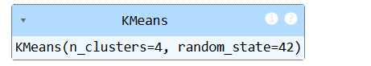
Kmeans_labels = kmeans.labels_
centroids = kmeans.cluster_centers_

plt.scatter(X[:, 0], X[:, 1], c=y, cmap='viridis', marker='o', edgecolors='k', label='Ground Truth')

plt.scatter(centroids[:, 0], centroids[:, 1], c='red', marker='x', s=200, label='Centroids')
plt.title('K-means Clustering')
plt.xlabel('Feature 1')
plt.ylabel('Feature 2')
plt.legend()
plt.show()

Output:
